GitHub link: (includes all the files of the project Lost & Found with Geo feature App, a demo video of it)

The screenshot of the main app screen:

Mainpage:

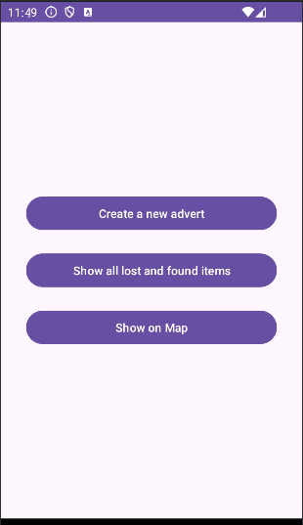

Add post activity:

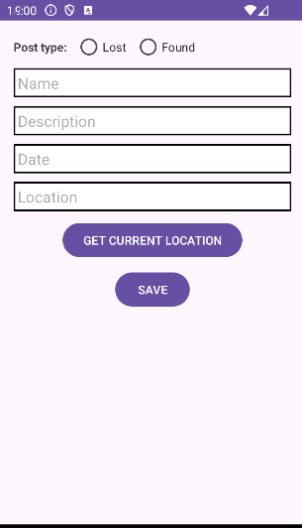

List all items activity:

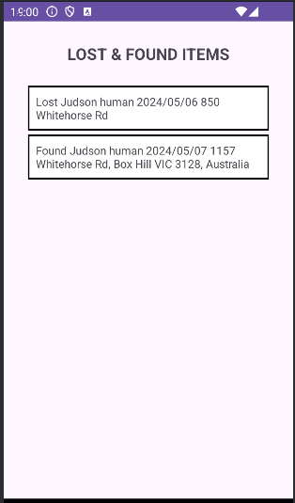

Show on map activity:

